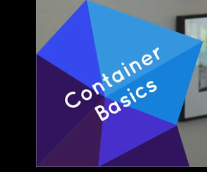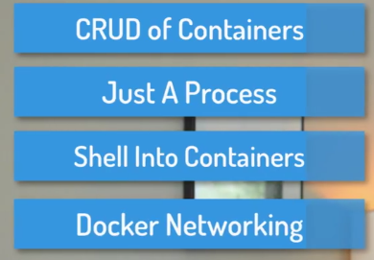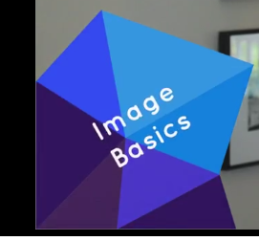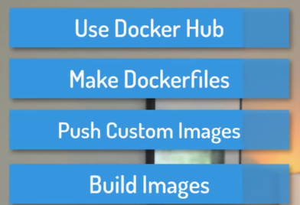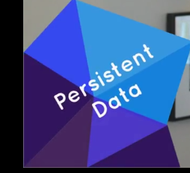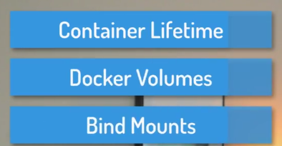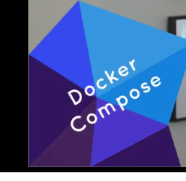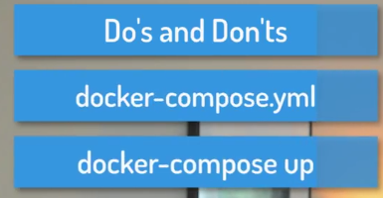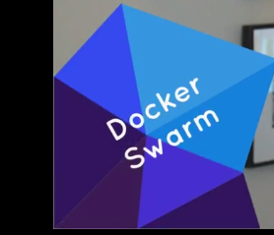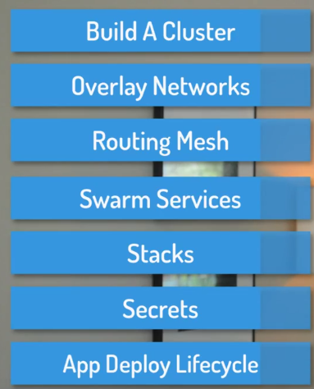

<https://github.com/bretfisher/udemy-docker-mastery>

chat.dockermastery.com

<https://dockermastery.slack.com/>

**Install:**

🡪Pro and Enterprise editions of Windows 10 (with latest update rollups).

["Docker for Windows" from the Docker Store](https://www.docker.com/docker-windows).

🡪**Installing on Windows 7, 8, or 10 Home Edition**

Unfortunately, Microsoft's OS features for Docker and Hyper-V don't work in these older versions, and "Windows 10 Home" edition doesn't have Hyper-V, so you'll need to [install the Docker Toolbox](https://www.docker.com/products/docker-toolbox), which is a slightly different approach to using Docker with a VirtualBox VM. This means Docker will be running in a Virtual Machine that sits behind the IP of your OS, and uses NAT to access the internet.

**NOTE**: For all examples that use http://localhost , **you'll need to replace with** <http://192.168.99.100>

**-🡪Installing on Linux**

**Do *not* use your built in default packages like apt/yum install docker.io** because those packages are old and not the Official Docker-Built packages.

I prefer to use the Docker's automated script to add their repository and install all dependencies: curl -sSL https://get.docker.com/ | sh

[play-with-docker.com](http://play-with-docker.com/) -🡪 4hrs

Editors:

Good free ones are GitHub's [Atom](https://atom.io/), Microsoft's [Visual Studio Code](https://code.visualstudio.com/), or even [VIM](http://spacevim.org/) if you're into shell-based editors.

🡪There may be mentions of 1.12  and 1.13  in this course, which were the two versions before 17.03 . 1.

13.1  is actually the same features as 17.03.0 , so if you see 1.13  on my screen recording and 17.04  or similar in your CLI, it's fine!

**🡪Big News:** **Docker versioning, release cycle, and product name has changed, but features haven't.** [Full details are here](https://blog.docker.com/2017/03/docker-enterprise-edition/), but my commentary on important highlights are below:

* **Docker Engine** (the free one we all know and love) **is now Docker CE** (Community Edition). Notice the drop of the word Engine. I suspect we can just call this Docker now. It includes the cli client and backend daemon/service and api (just like it did before). You can get it the same ways as before.
* **Docker Data Center is now Docker EE** (Enterprise Edition) and adds additional [paid products and support](https://store.docker.com/search?offering=enterprise&type=edition) on top of Docker in three pricing tiers.
* These changes don't affect Docker Compose or Docker Machine.
* **Docker's version is now YY.MM  based**, using the month of its expected release, and the first one will be 17.03.0 , which is "the first point release" of the 17.03  release. If any bug/security fixes are needed to that release, the first update will be 17.03.1  etc.
* We now have two release tracks (called variants) "Edge" and "Stable".
  + Edge is released monthly and supported for a month.
  + Stable is released quarterly and support for 4 months.
  + You can extend Stable's support and backported fixes through a [Docker EE subscription](https://store.docker.com/search?offering=enterprise&type=edition).

# 02-creating-and-using-containers-like-a-boss

1. 009-check-our-docker-install-and-config:

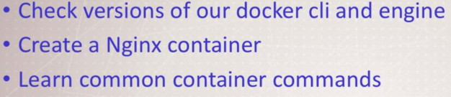

Docker Engine is Docker daemon (runs in background) or docker service (Windows). It’s core of docker.

Commands we run talks to daemon over API

1. 010-starting-a-nginx-web-server:

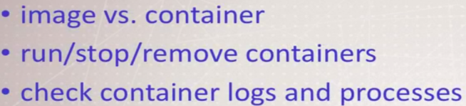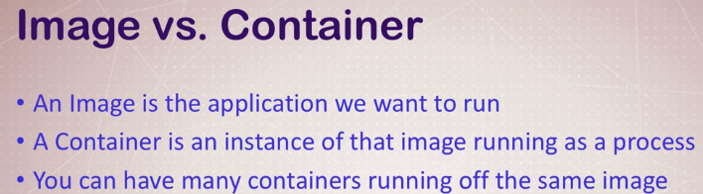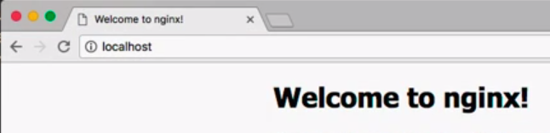

1. 011-debrief-what-happens-when-we-run-a-container

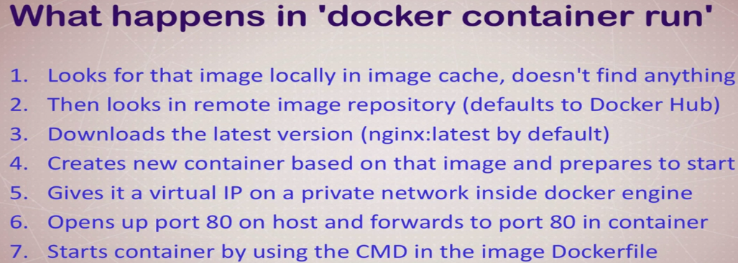

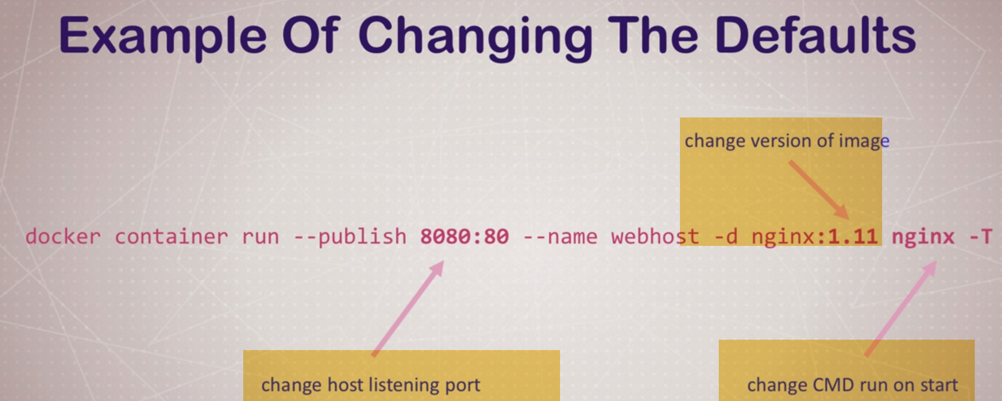

4.)012-container-vs.-vm-its-just-a-process

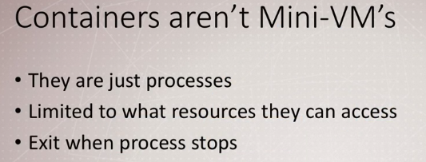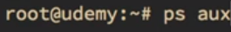

You can see this on host process running with different processID, because of security layers.

🡪Windows Containers  
(Windows Containers: Docker Is No Longer Just Linux )

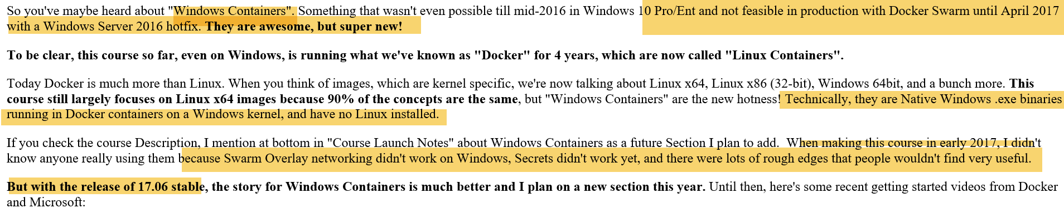

-🡪 014-assignment-manage-multiple-containers:

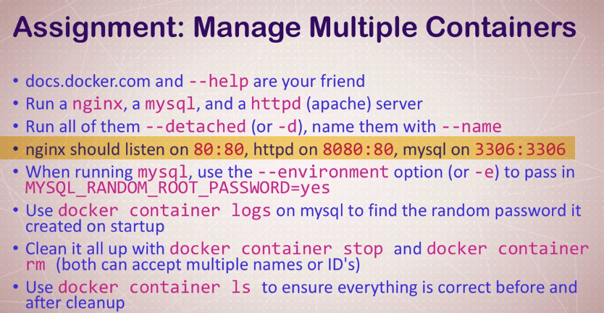



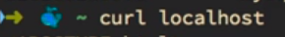

**🡪016-whats-going-on-in-containers-cli-process-monitoring**

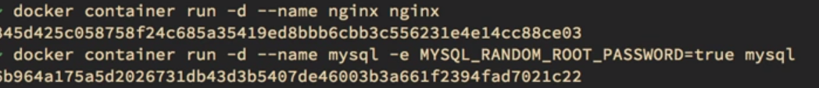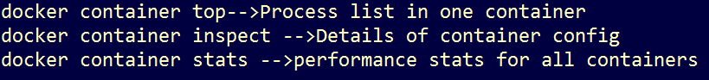

**🡪017-getting-a-shell-inside-containers-no-need-for-ssh**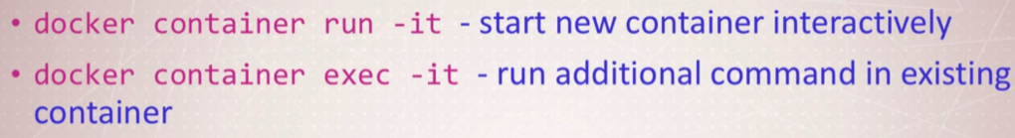





**-🡪 018-docker-networks-concepts-for-private-and-public-comms-in-containers**

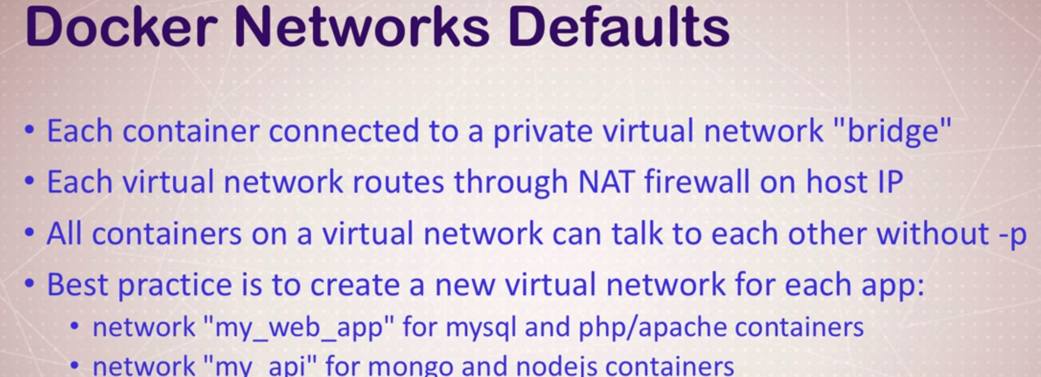 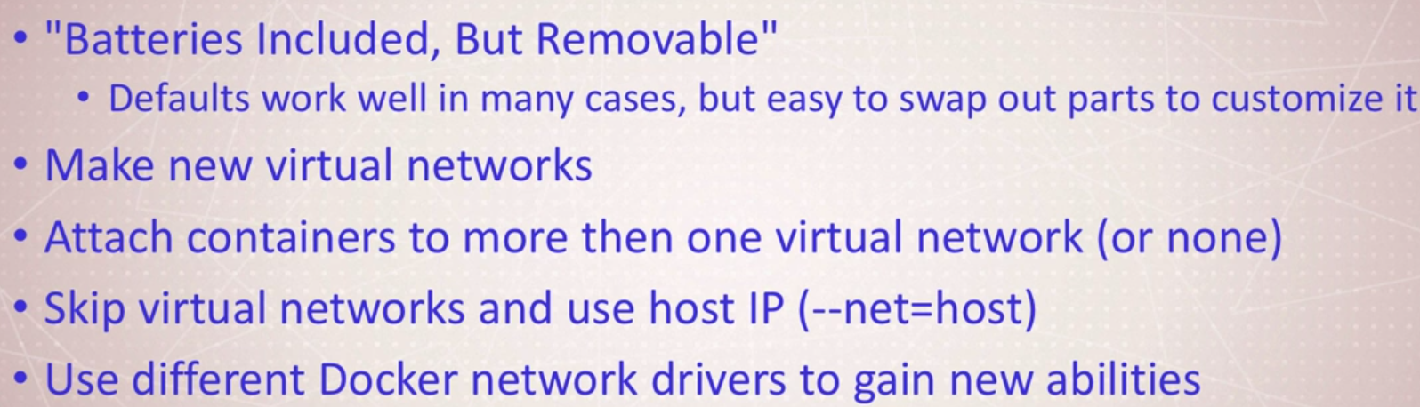

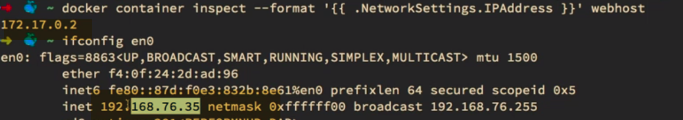

 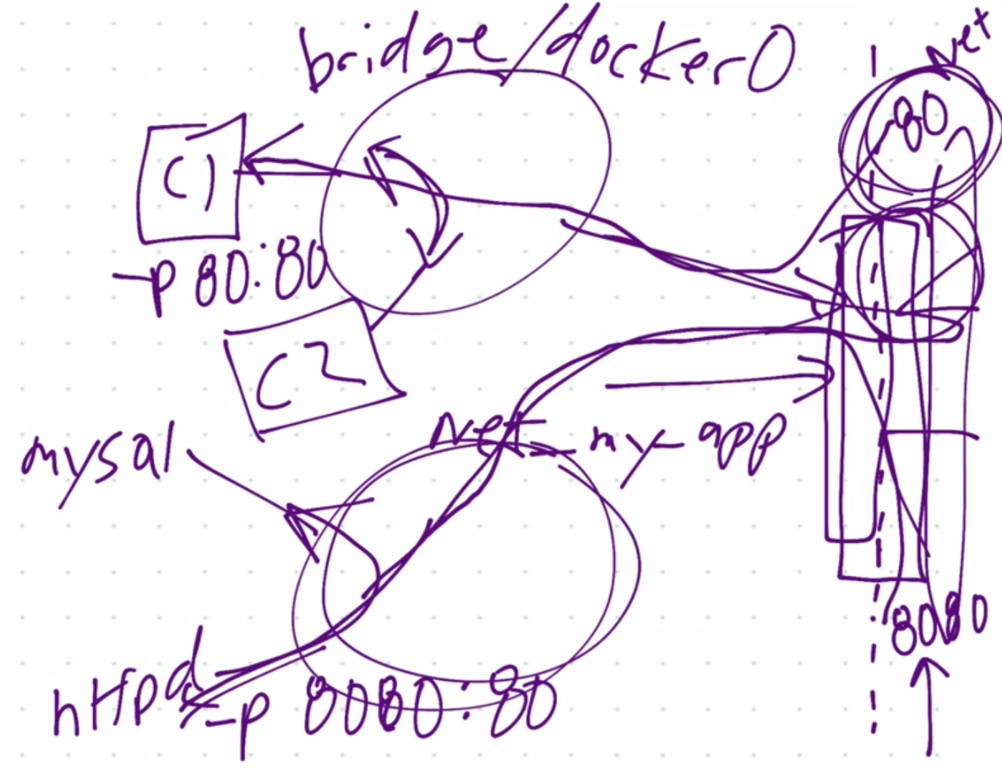

**020-docker-networks-cli-management-of-virtual-networks**

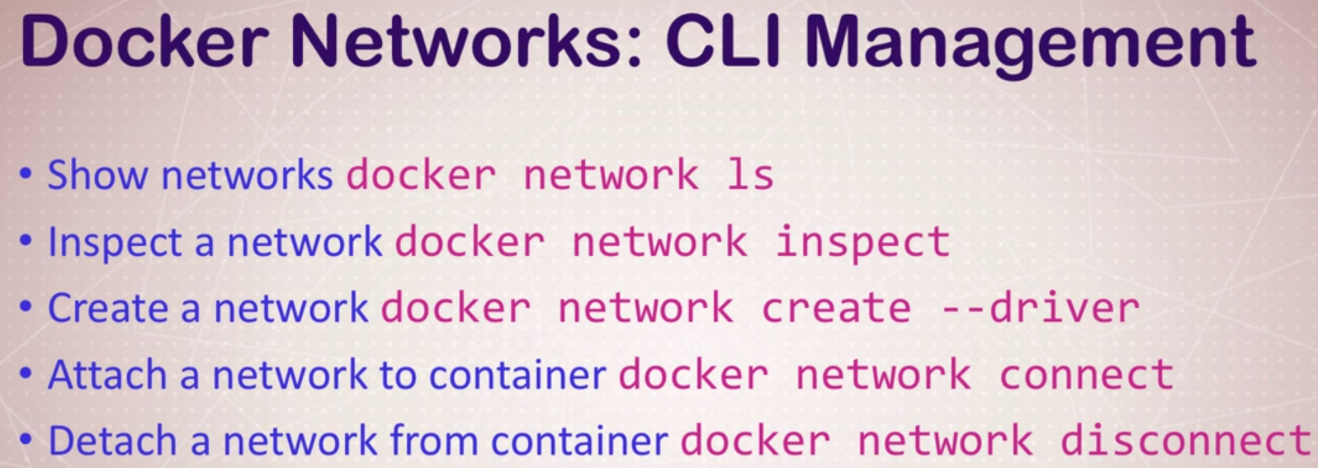

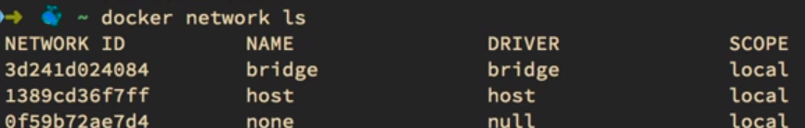

Bridge -🡪 Docker0🡪Default🡪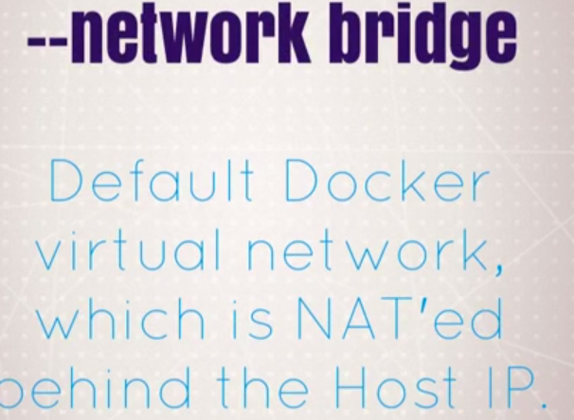

Host🡪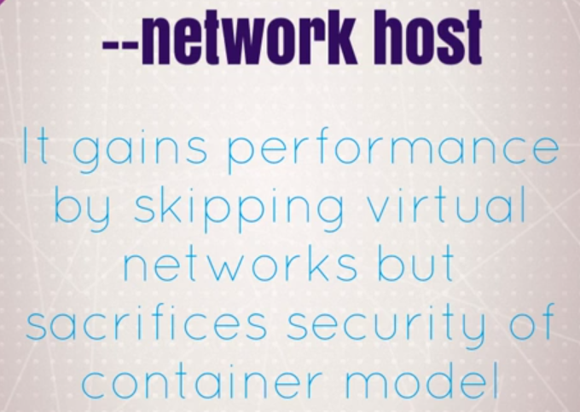

Skip Virtual networks and attaches directly to host interface.

None: 🡪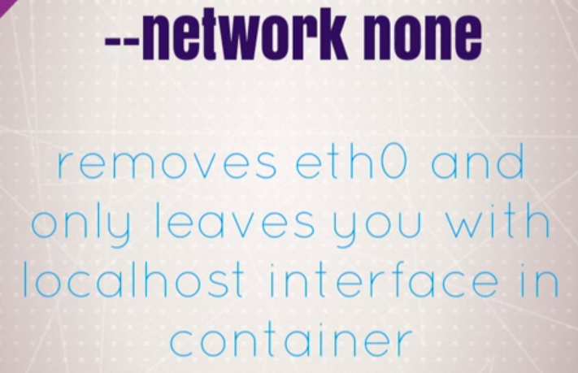

Not attached to anything

-🡪 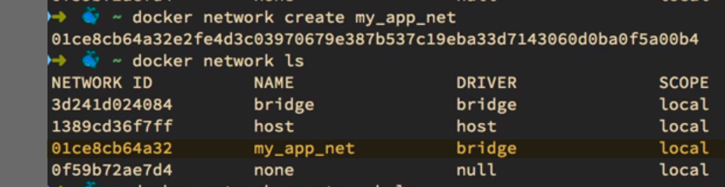

Creates network with Driver as Bridge... 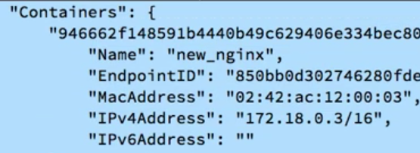🡪On new n/w with IP: 172.18(next subnet in list).

We can plug and replug wireless n/w devies with new or existing containers.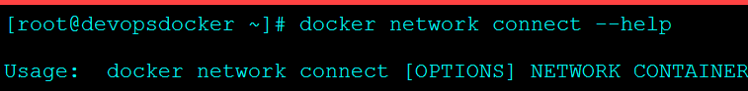

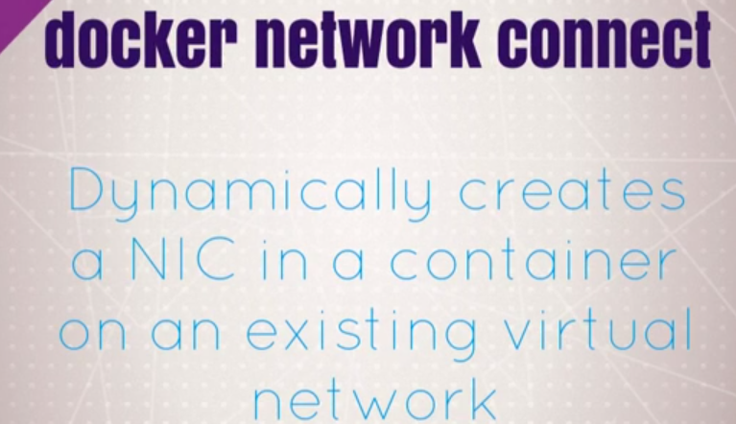

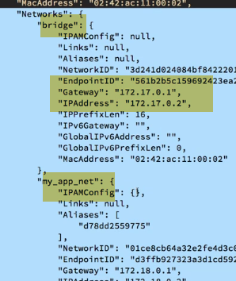Now it is on bridge0 and my_app_net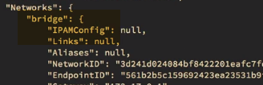

Only on bridge now..

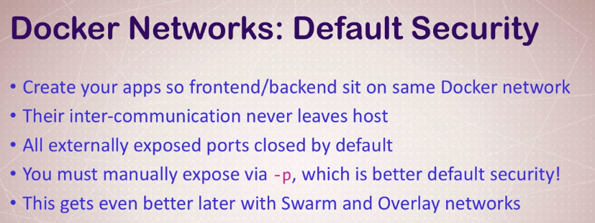

No over-expose of ports

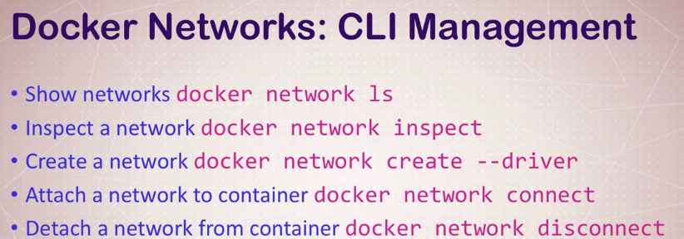

**-🡪021-docker-networks-dns-and-how-containers-find-each-other**

We cant rely on IP address because they are dynamicc

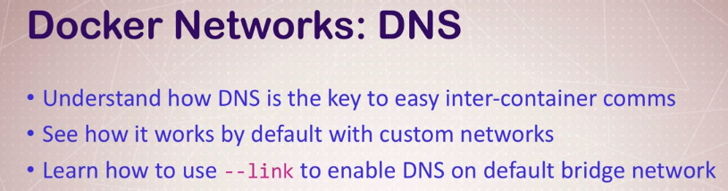

Containers should talk to each other. In world of container, Creating, Destroying, launching, moving, shrinking ---We can’t really rely on IPaddress as way to talk with other.

From minute to minute, we cant assume IPaddress will be same.Container might fail and docker will bring new one..

Sol: DNS naming. Docker uses container names as equivalent to hostnames for containers talking to each other.

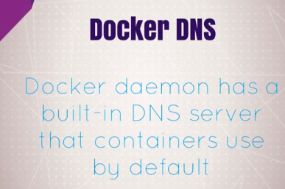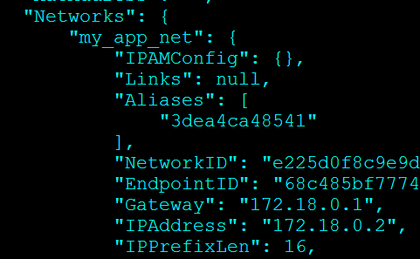

New_nginx is on new n/w, my_app_net which is not default bridge n/w..It will get special new feature which is automatic DNS resolution for all containers on virtual n/w, from all containers on virtual n/w using container names..

If we create new container on that virtual n/w, they are able to find each other regardless of their IP address using container names..

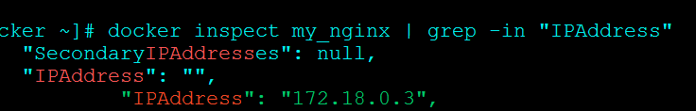---New one

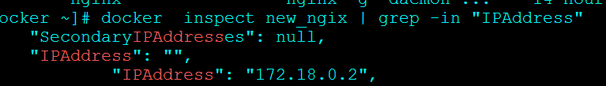---Old one

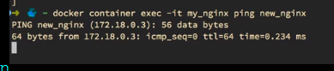

**DNS resolution just works. It makes super easy to have one container, and need to setup configuration file to talk each other (php server talking to mysql backend).**

🡪 This will solves our big issue,.., as we cant predict how long container lasts and where they will be a minute from now..

In Production design , you have cluster of docker swarm services..

If we stop and start containers in different order, they may not have same ips.Container names or hostnames will be same.., where we can rely on..

-🡪 **Default bridge have one disadvantage here. It doesn’t have DNS server built in by default. So you have to use –link**

**docker container create --help**

When we create containers, there is link option. You can specify manual links b/w container in default bridge n/w. But it’s better to create new n/w .So No need to create links for new n/w..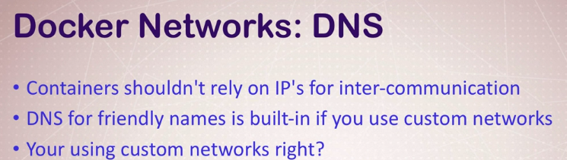

-🡪 **022-assignment-using-containers-for-cli-testing**

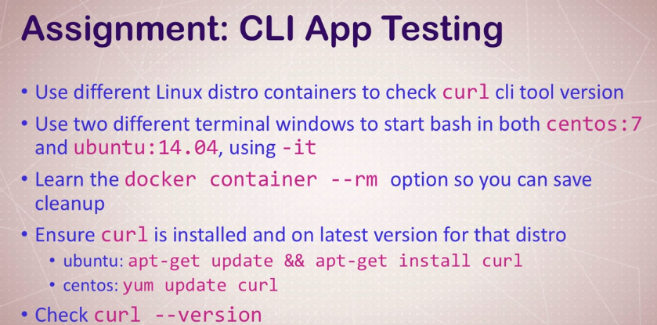

**-🡪 023-assignment-answers-using-containers-for-cli-testing**



**-🡪** **024-assignment-dns-round-robin-test**

**dns-round-robin-test:** 2 diff. hosts with dns alias that responds to same dns name..

Ex: google dns.. They have more than one server ..To make, always up 24/7 may employ dns-round-robin strategy. So that multiple Ip address and DNS records behind name using on internet...

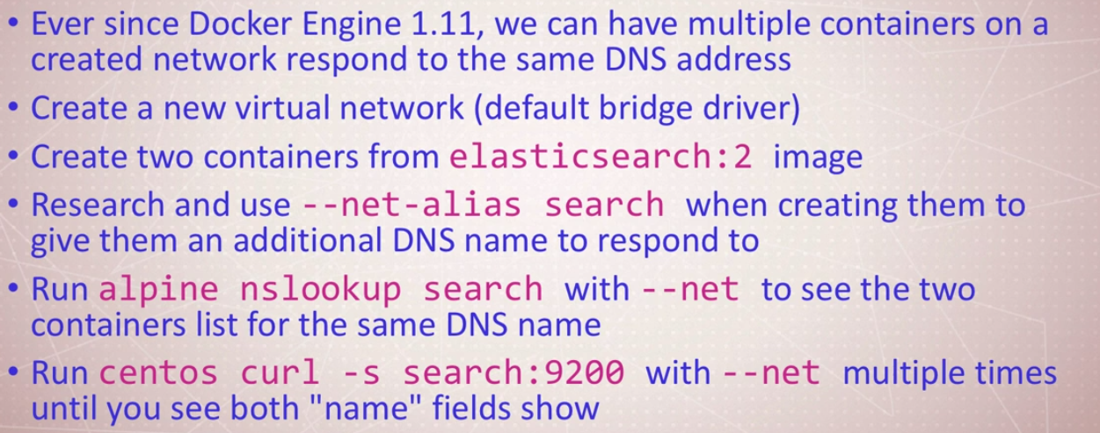

🡪--net-alias search—Option in Docker run.

When we start container, we will tell : I want another dns alias to call this container by, not just by container name..

This will get around problem..

As we add containers, we realize that we cant add containers with same name.. But how to resolve DNS for same app installed twice??? …Dev, Test env. On same docker server and call search in both of those..

**Container Images:**

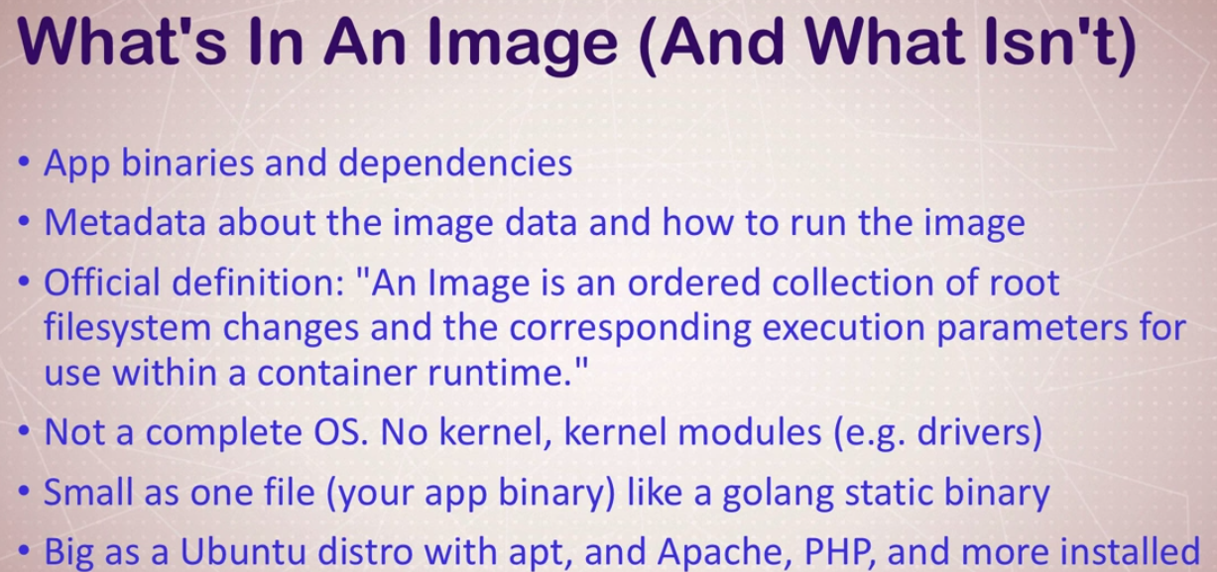

**027-the-mighty-hub-using-docker-hub-registry-images**

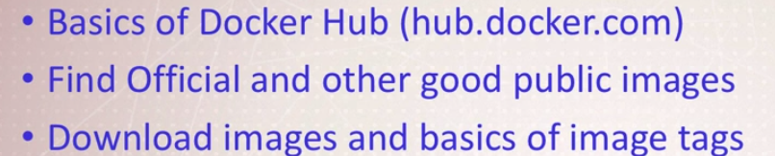

**Difference b/w official and others…**

* They have word Official below it … They have **quality documentation** and practice rules..
* They have versions also..1.10, 1.13 etc.. They have support

And others we have to create with Account name in front of them.

**A version of image can have many tags**

-----------------------------------------------------------------------------------------------------------------------------------------

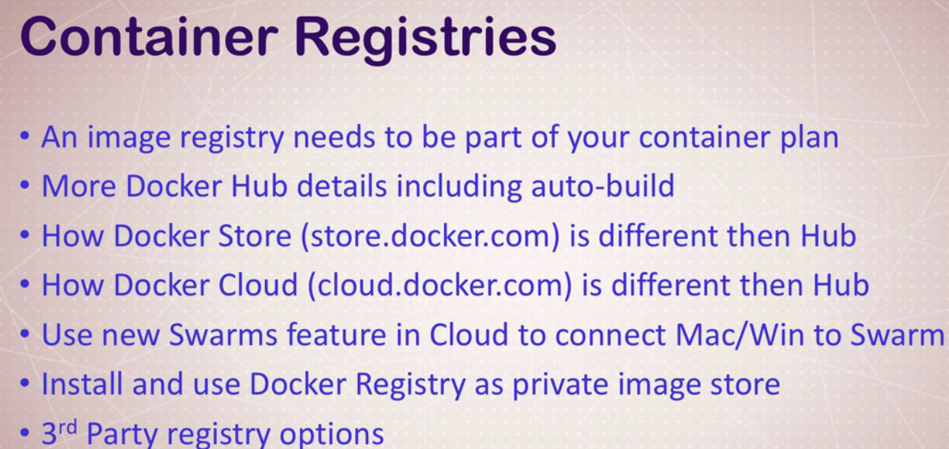



**View of repository**

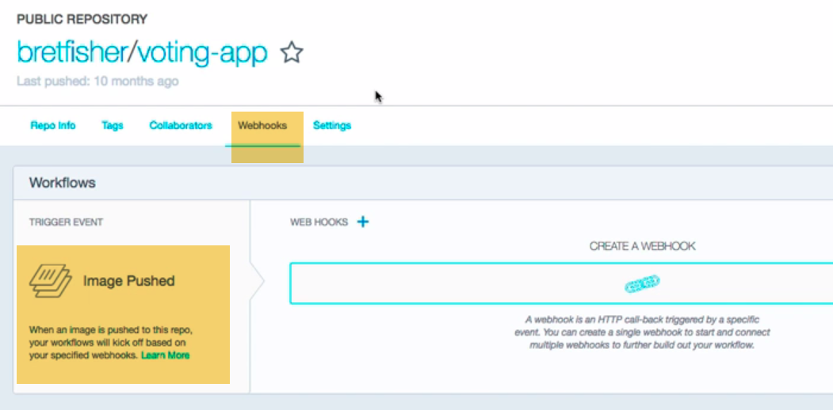

**Settings:** make private/public

Delete repo.

**Webhooks:** When images are built and pushed to docker hub, we have Webhooks to other service like Jenkins or TravisCI to have automated builds.

Webhooks are there to help you automate process of making code all way from github to docker all way to prod..

**Collaborators:** We can add users so they can make changes to image

🡪 We also have **Organizations**, where we can have our own permissions to repo.., and give other permissions to repos..

If we want to create Org...We can create---totally free 

We can have teams, billing for private..

Everything opensource is free… Everything to be private pay for it(similar to github)..

1.) If we are using GitHub/bit bucket to store your code..,

Don’t do:

---Docker push and 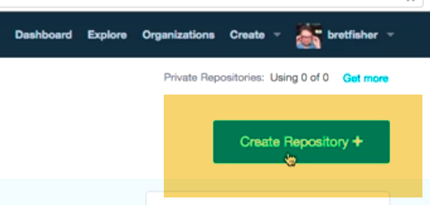

Don’t use click Create repo…to store repository

2.) All want to do is , Create Automated Build

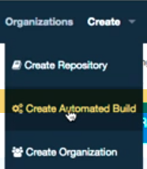Create Automated build allows creating CI path that will automatically build image based on code commits...

This is like reverse webhook. The webhook that we used before are..Dockerhub to notify when something else finished up with an image.

This process allows docker hub to be notified, when something else happens 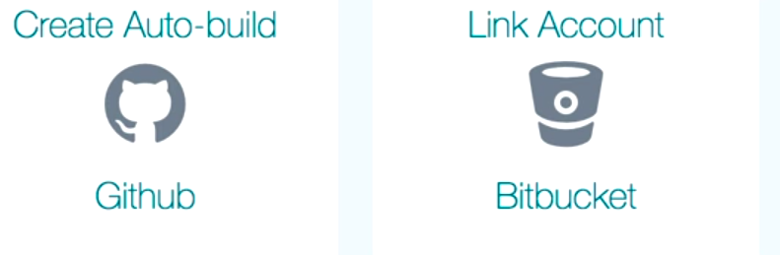

Whenever code commits on a branch.., it will build image on fly..and we will get emails successful or not. 

This ensurses this image is up-to-date whereever source code is…

We have Build details…Where other doent have this option..

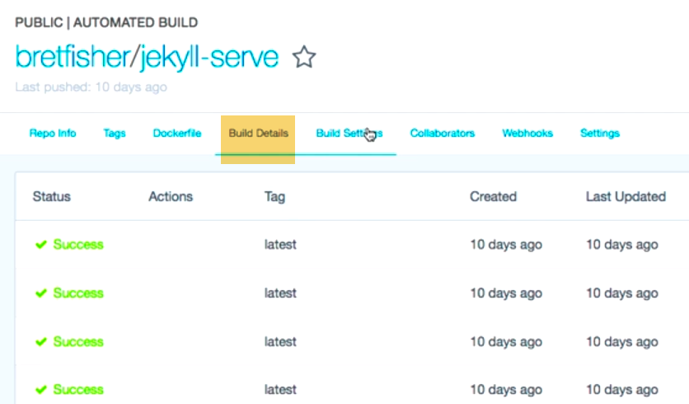

Build history…

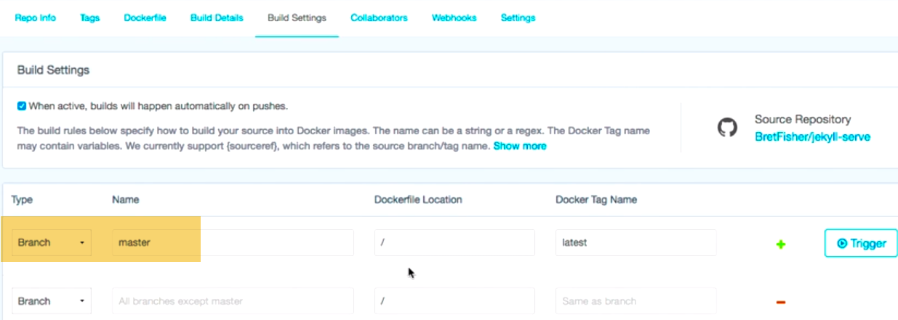

Which branches to build.

Recommended:

**1.)Build Settings🡪Repository Links**

**If you are building images on Dockerhub, and using From statement that pulling from some other image..We need to setup repository links here.So that when ever that software changes this image will get rebuilt.**

**That’s a big deal. Because over-time your image is going to have dependencies on it and needs to update when those get updated due to security requiremnets or new bug fixes etc..**

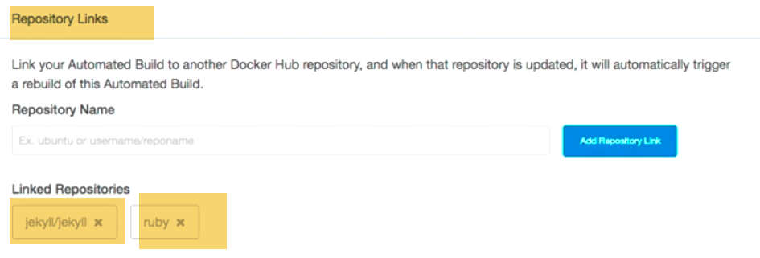

**From statement here uses Jekyll, ruby…Anytime these changes…My images will be rebuilt**

2.)If we want to create build triggers..It is an inbound way to get image built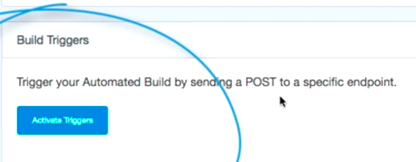

-----------------------------------------------------------------------------------------------------------------------------------------





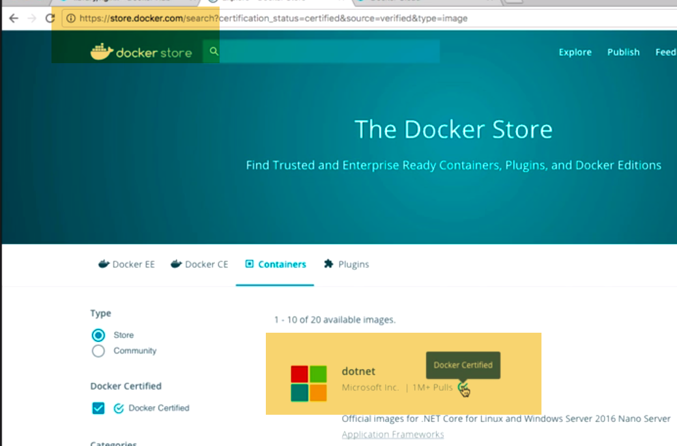

Docker certified images…

Docker hub is like github of images

Dockerstore is like app store for images (more specific apple store for images)….**We pay for images**

Only way it gets it here is…, their partner work with docker to get official s/w into store.

May be paid or free.

**EX**: 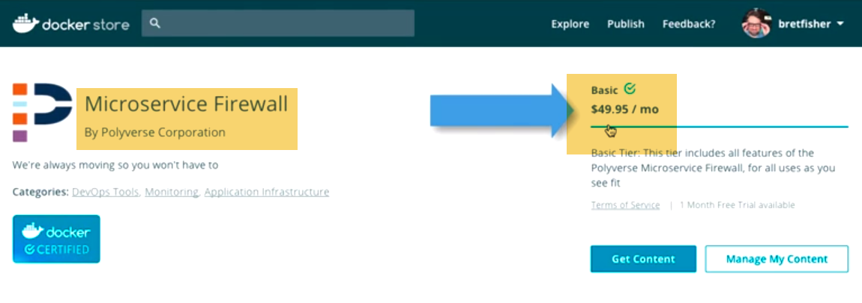

-----------------------------------------------------------------------------------------------------------------------------------------

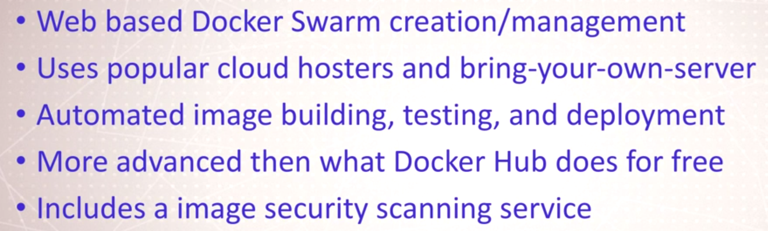

Docker cloud is not cloud hoster.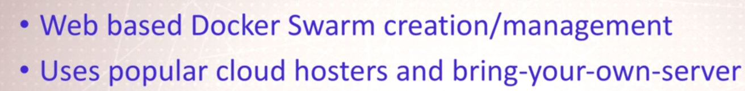

For Cloud: AWS, azure if we don’t want to use CLI to deploy apps or manage servers …Use docker cloud

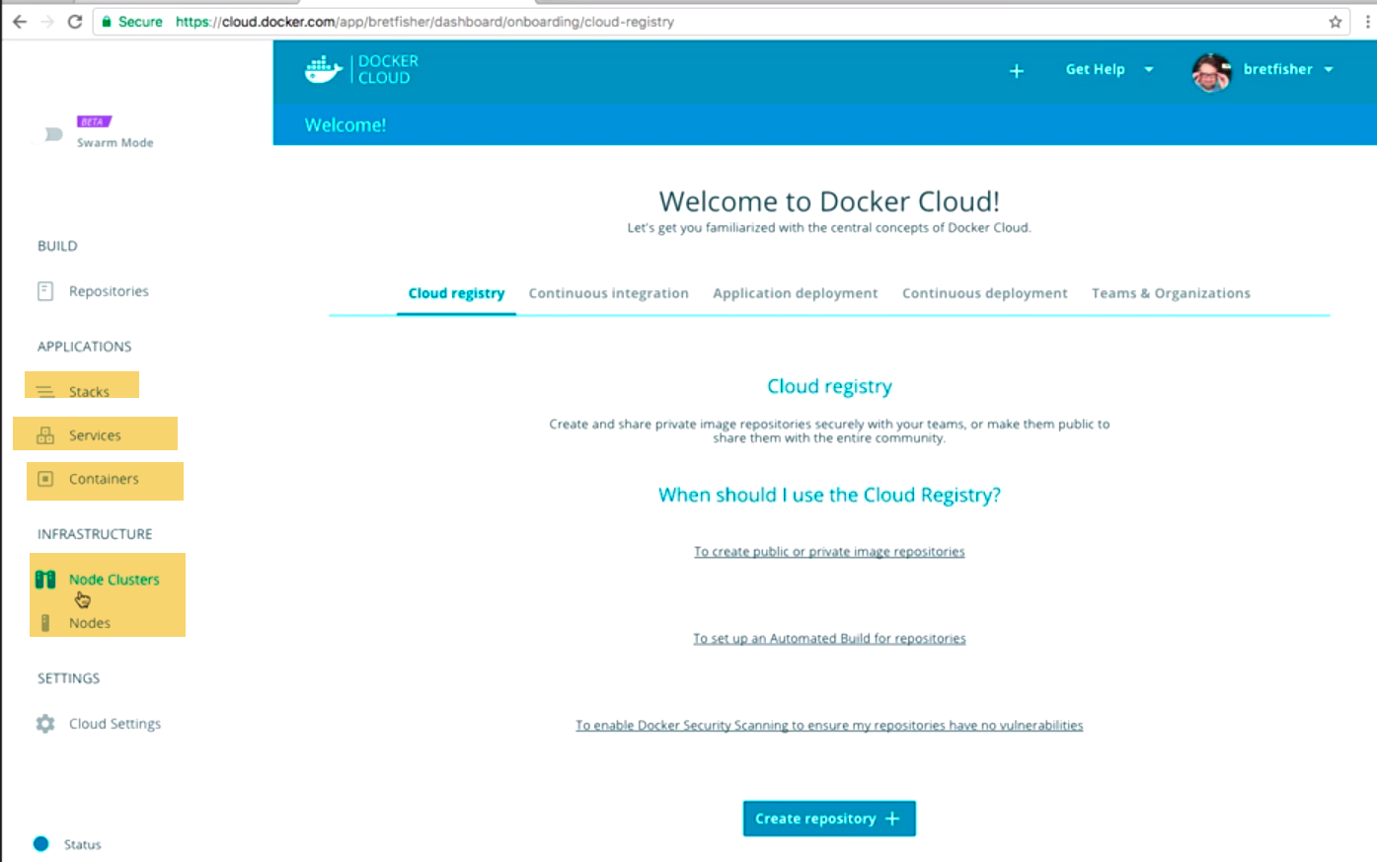

We can create nodes clusters here:

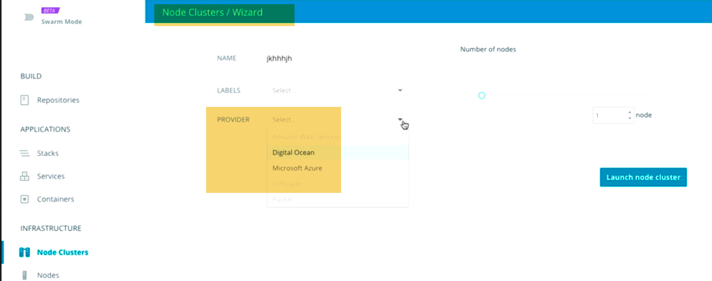

This helps to create codes on Cloud hosters..This will same me few steps while deploying infrastructure..

When, once infra. Is created into clusters…Copy and paste stack files in .., and there we go.

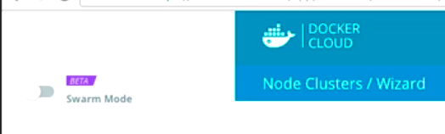

This beta feature allows to create/manager 1.13 swarm modes.

**Build:**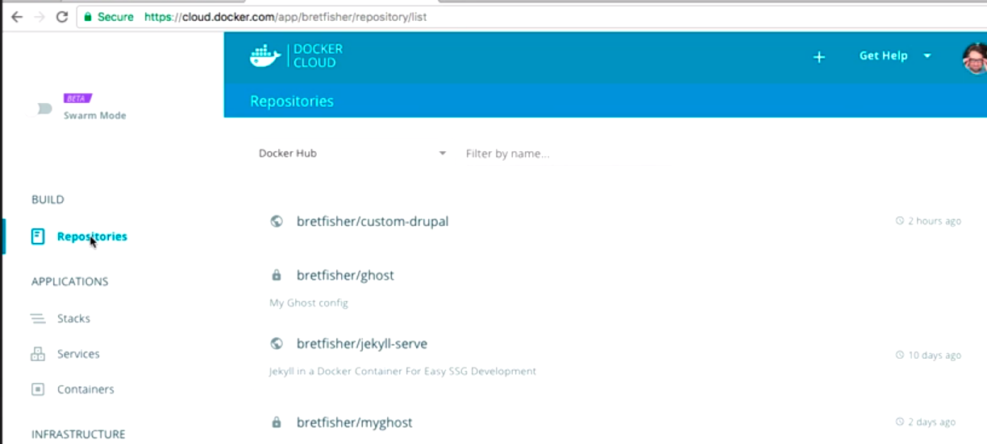

**On Docker hub, where we can do automated builds of images.Dockerhub inc. Webhooks from github.**

**In Docker cloud: We have pay to have more features like:** 

One stop for CI platfoem: Build, test,deploy to servers.

Click on one repo:

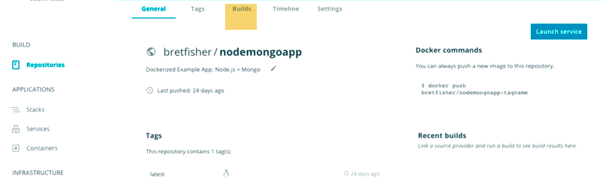GotoBuilds: 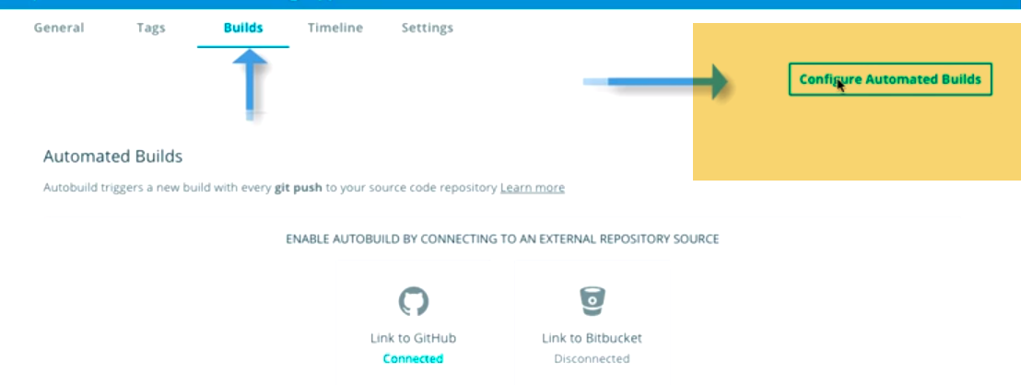

-Also includes security scan for vulnerabilities.

For vulnerabilities:

Goto dockerhub:

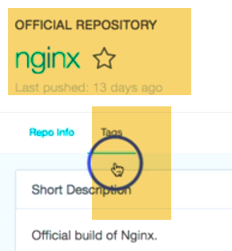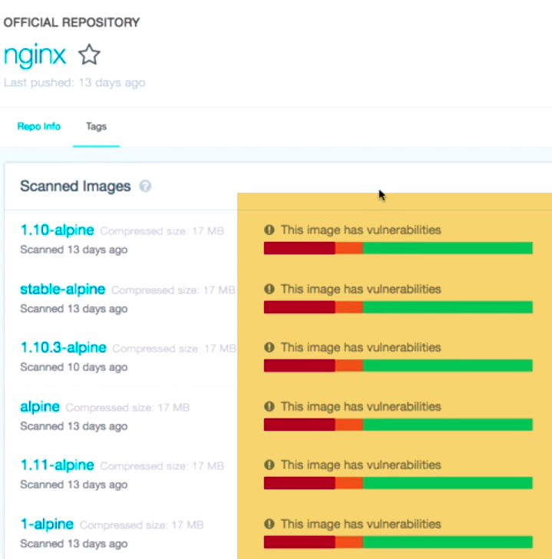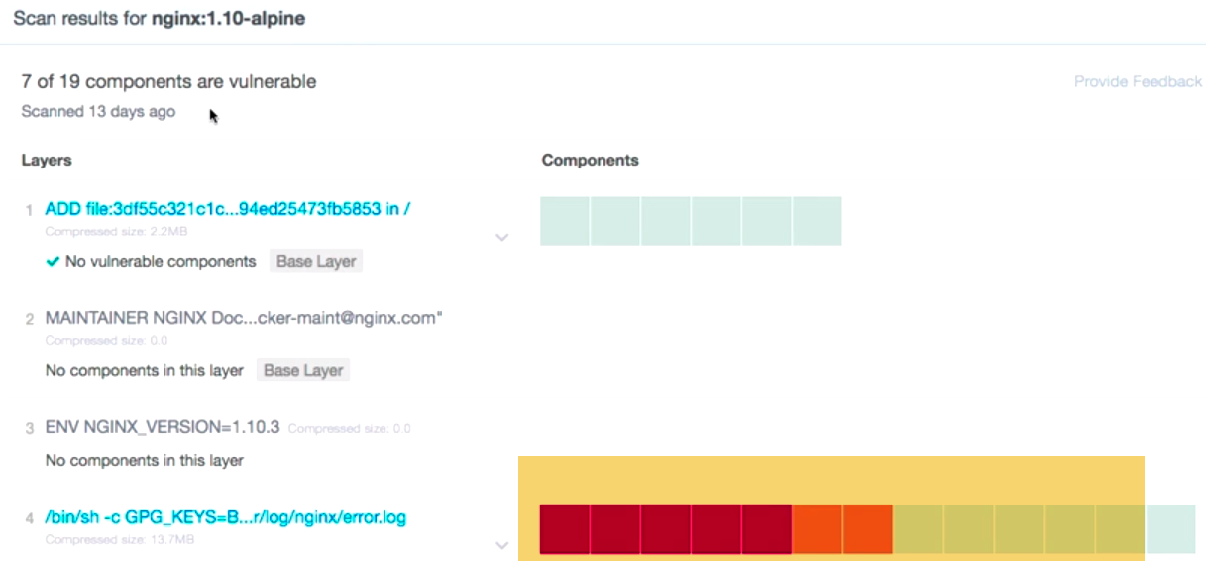

We can see on which layer vulnerability issue occurred in.., and what those vulnerabilities are…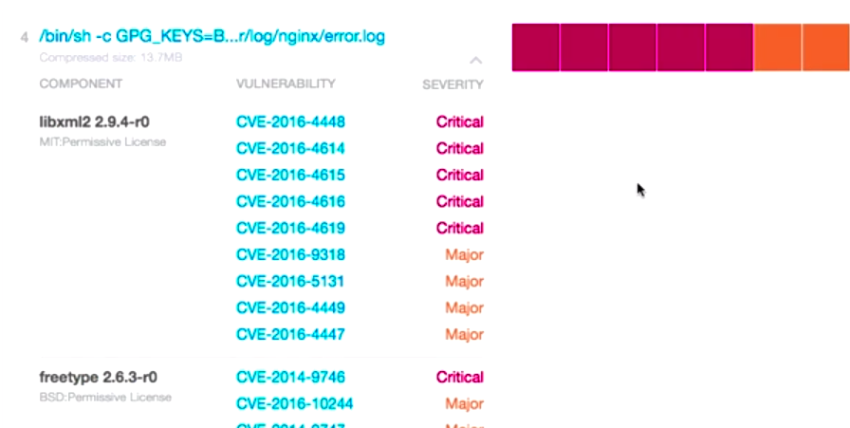

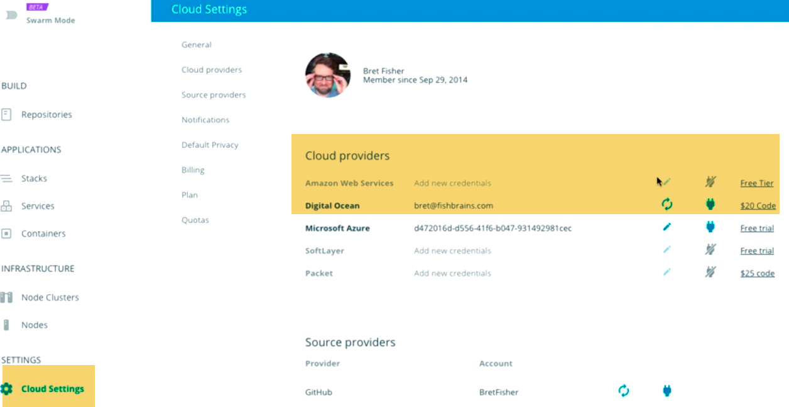

-----------------------------------------------------------------------------------------------------------------------------------------

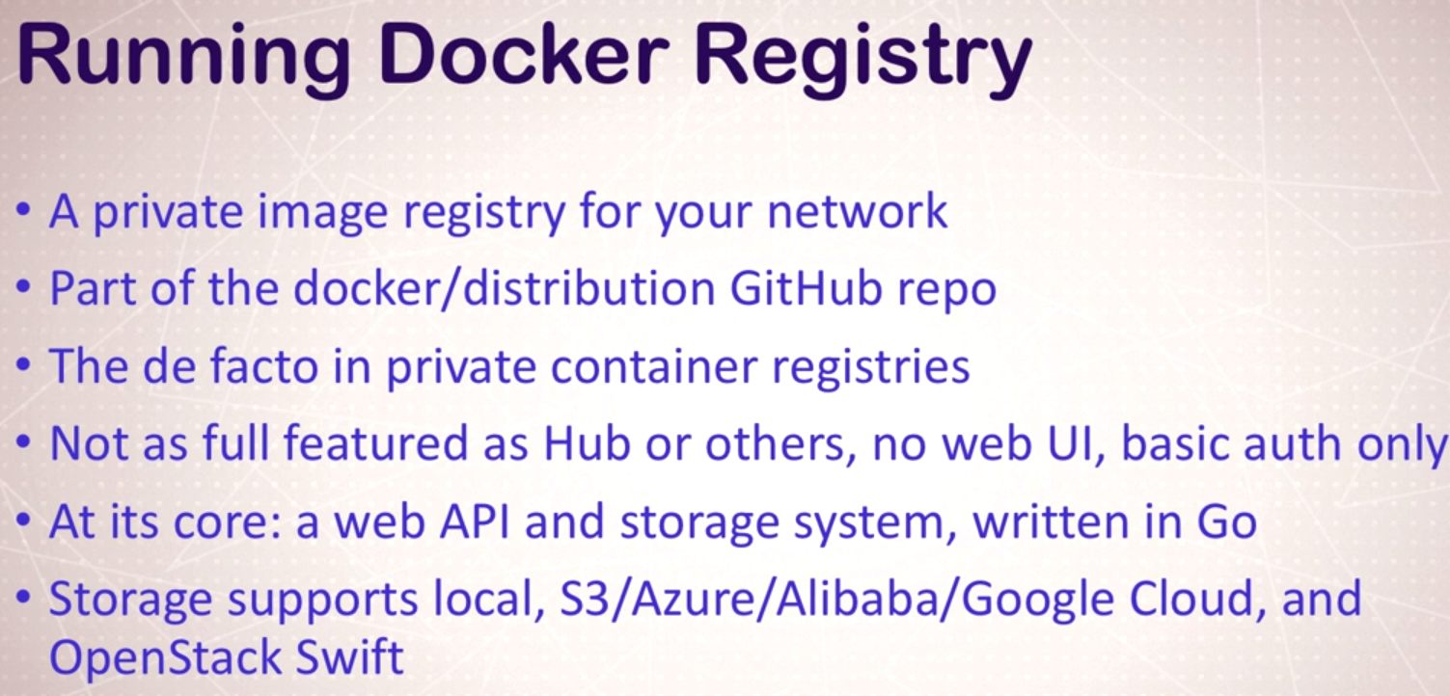

---No Web gui …Like dockerhub or third party service.

I supports certificates and basic authentication, but not enabled by default.

Authentication default is none enabled. Access is not role based. More like apache, if we know user and password.., we can get through.. and access to everything.

Useful for small teams

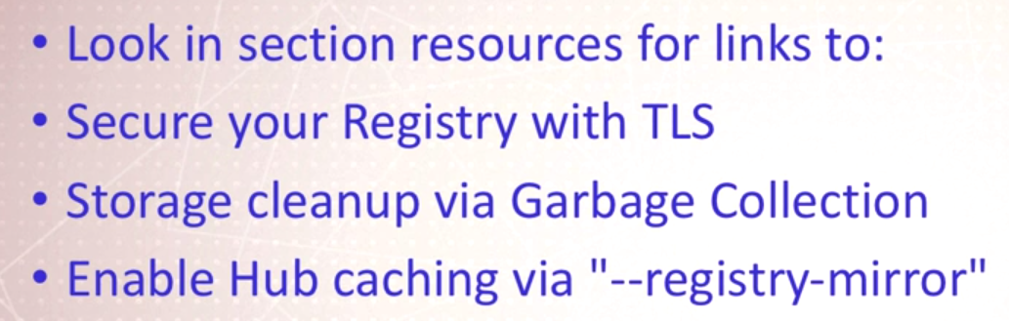

--Cleanup old things, and keep storage on check

--When we are deploying to Prod, and if we don’t want to depend on hub a lot for base images..then we can enable proxy mode(--registry-mirror) ..

Tell Docker daemon to use proxy..Cache images inside registry, which is great if we want to optimize Bandwidth.

If we want Ubuntu image, we don’t want to download on each and every m/c from hub.

-----------------------------------------------------------------------------------------------------------------------------------------

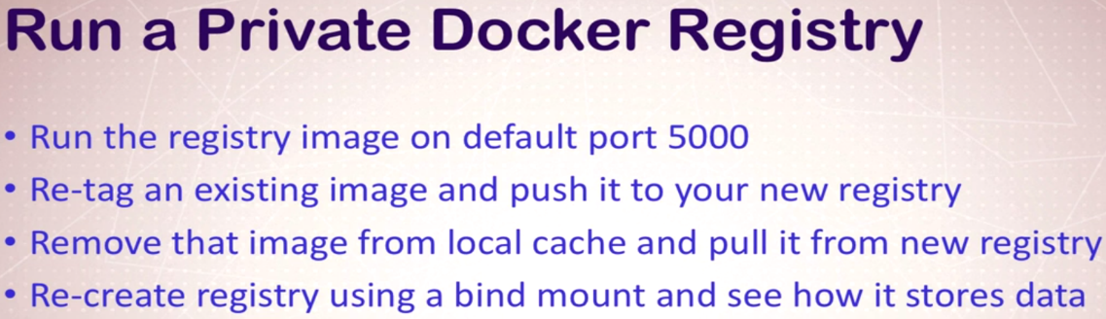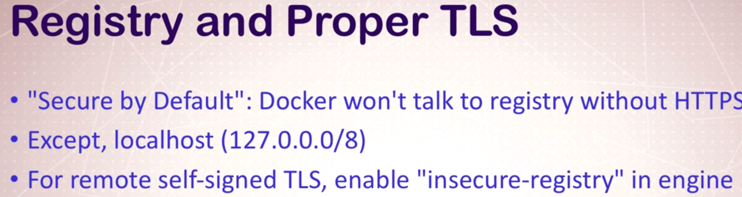

------🡪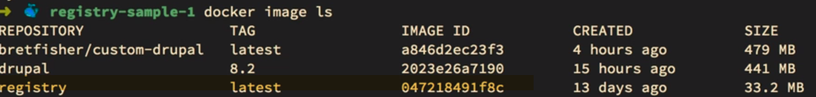

🡪With images on Dockerhub have, we need to have format to **a/c name-repository name.**

**For any other registry:we have to use with host as well.**

**-🡪**

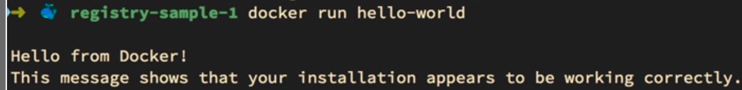

**---How to push this to local registry????**

**I need to give other tag.., which tells demon where to send.**

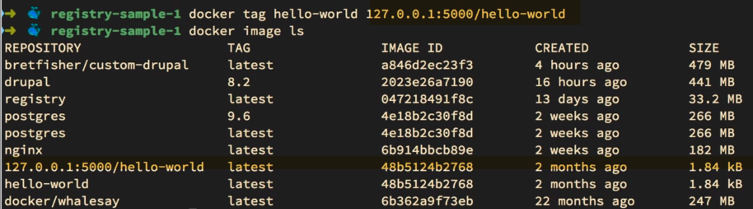

**Equivalent of making my own official image, at root of local registry..**



-🡪Delete local images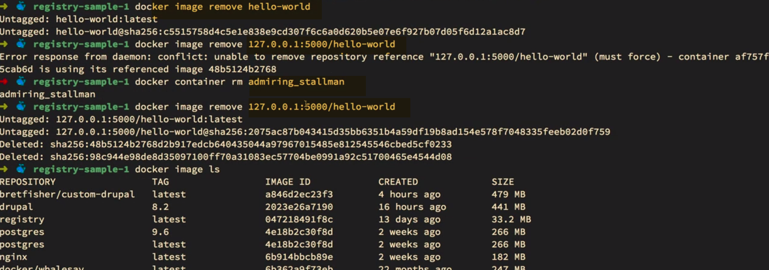

-🡪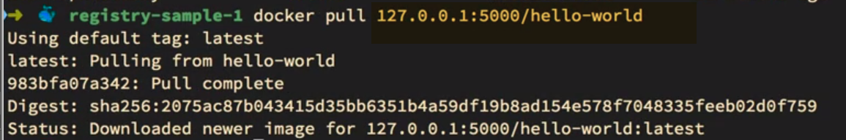

We have images locally now.

-🡪If we are going to use local registry always use volume for storing data.

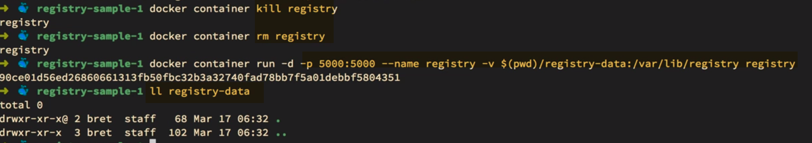

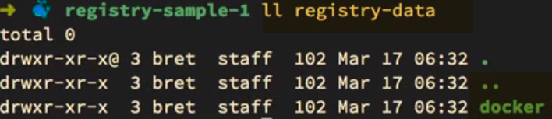

Summary: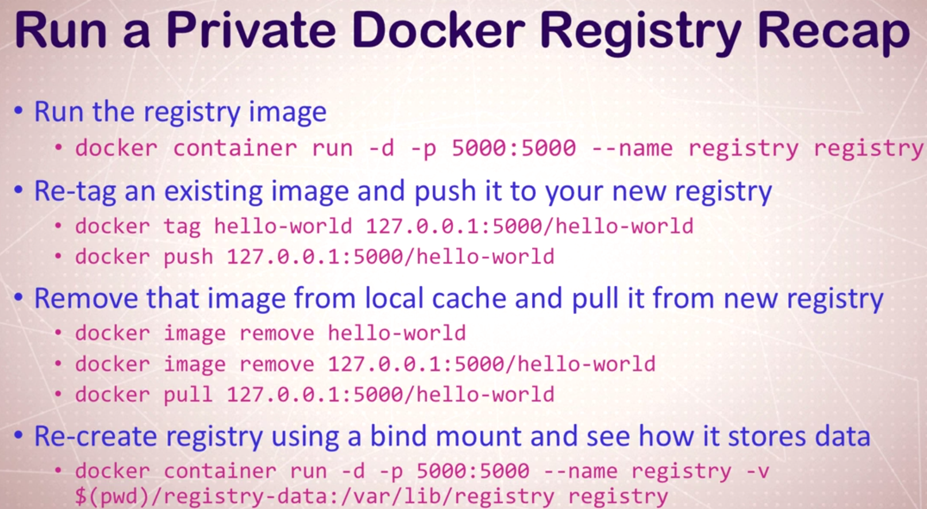

(Next)-Secure Using TLS

-Enable authentication.

-----------------------------------------------------------------------------------------------------------------------------------------

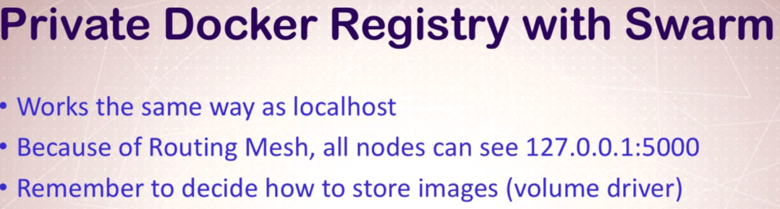

-🡪 <https://play-with-docker.com>

5 managers –No Workers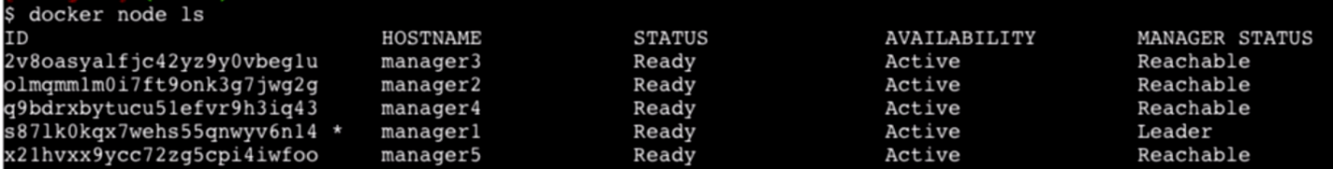

Lets run registry now.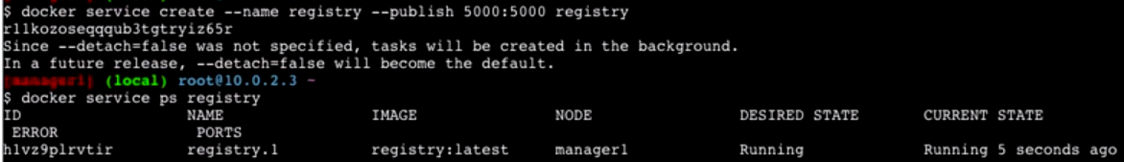

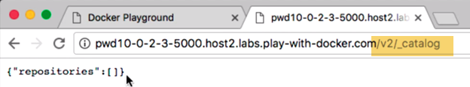

-🡪

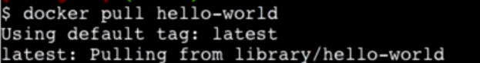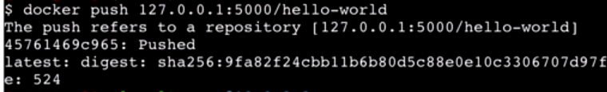

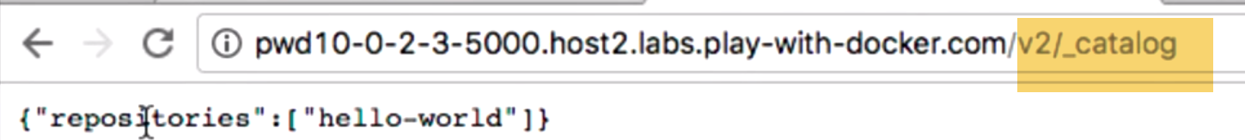

Now show repos

-🡪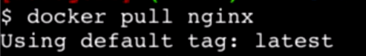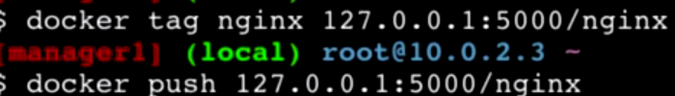

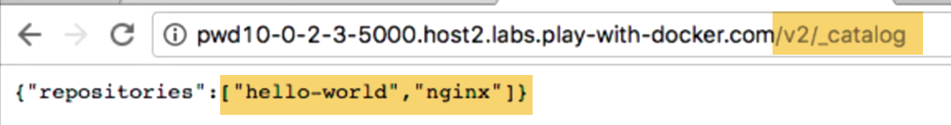

-🡪 Telling we don’t want to use docker hub, and want use local one

--replicas 5-🡪 start nginx on each one.

--detach=false🡪Allows to see commands running in real time

Preparing🡪Downloading images form registry to nodes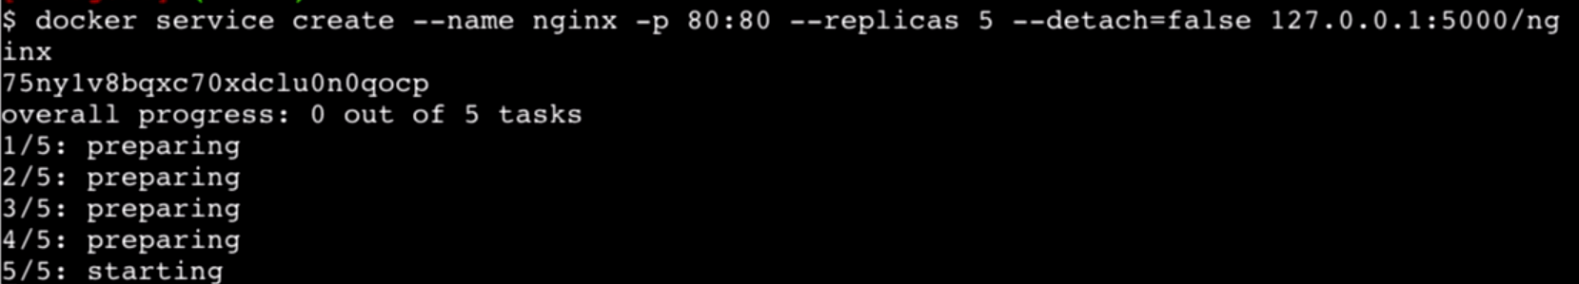

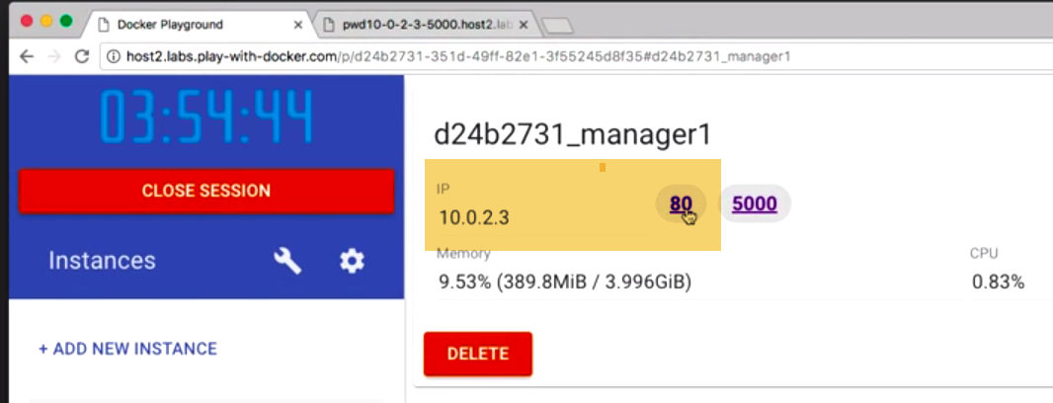

Now, we can see port 80 now. 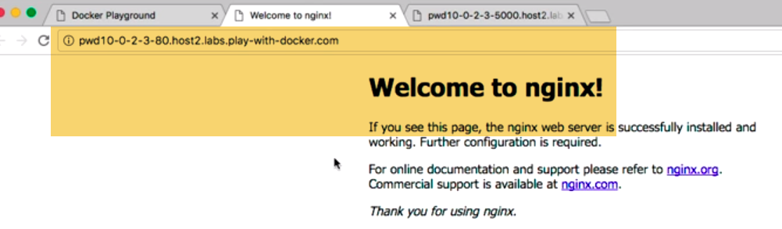

Note: In a swarm, you cannot use image on One node.Swarm has to pull images from repo. To locally to each node..

Each node one have to push/pull seperatley from central repo. 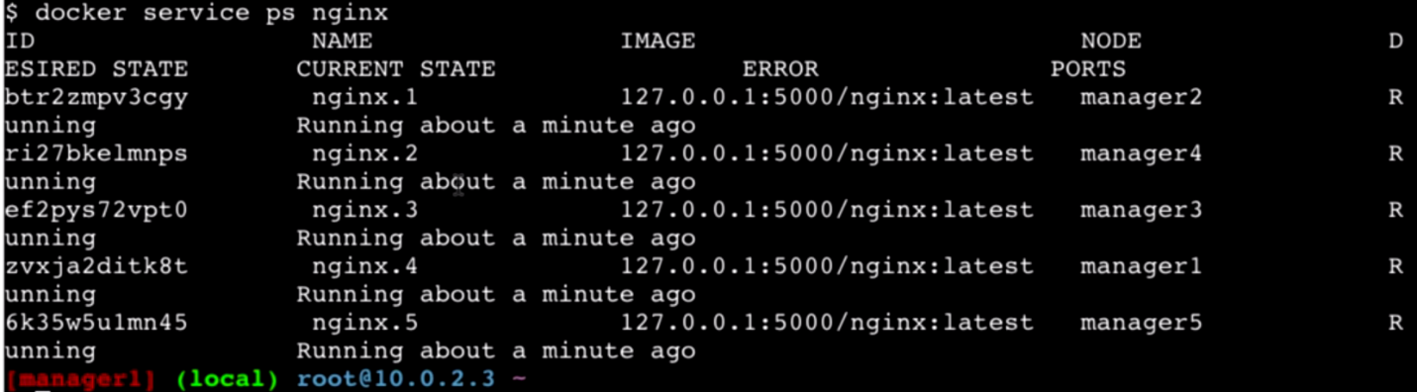

One running on each node.., and image used is from registry.